
Document Number: RA02

Application Form Carer

STRICTLY CONFIDENTIAL Application for Employment Please type or complete this form in black ink

POSITION APPLIED FOR

Date of Application

PERSONAL DETAILS

Surname |  | First name(s)
Address |  | Previous
 |  | Name(s)
 |  | Home Telephone
 |  | No.
National Insurance |  | Mobile No.
No.
Immigration Details |  | E-mail
Please notify us of any dates you are available for
an interview:
Are you a citizen of the EU? |  | Yes |  | No
Do you need a work permit? |  | Yes |  | No
Current driving licence? |  | Yes |  | No
Do you drive? |  | Yes |  | No
How do you usually travel to work?
NEXT OF KIN


Surname

Address

First names

Relationship

Telephone

Vibrant Healthcare Recruitment, 88a, Princes Avenue, | Reviewed: 12-02-2023
Chatham, Kent, England, ME5 8AH, | Reviewed: 12-02-2023
Phone: 07380980551
Email: info@vhcr.co.uk | Website: www.vhcr.co.uk

Document Number: RA02

PREVIOUS EMPLOYMENT

Full employment history must be detailed, beginning with your current employment and covering all reasons for gaps in any given year.


Date

From | To

Employer’s name | Position held | Salary & | Reason for
(most recent first) | Position held | Benefits | leaving

Document Number: RA02


EDUCATION

(Original documents as proof of qualification will be required at the interview)
Secondary school/College/University | Examinations taken | Result

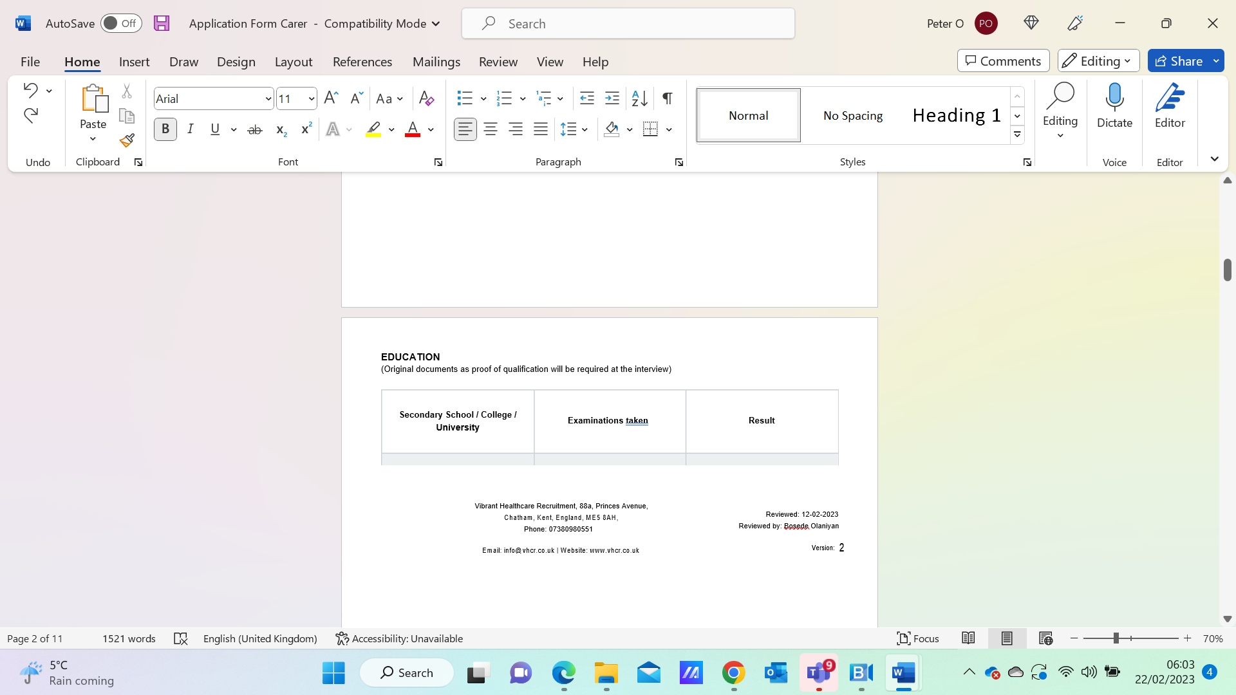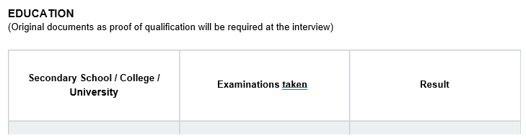

MANDATORY TRAINING

Please tick if you have completed the following training within the last 12 months.

Please enclose copies of your training certificates

Moving and |  | Basic Life |  | Intermediate Life |  | Advanced Life
Handling |  | Support |  | Support |  | Support
Complaints |  | Handling
Complaints |  | Violence and |  | Fire Safety |  | COSHH
Handling |  | Violence and |  | Fire Safety |  | COSHH
Handling |  | Aggression
RIDDOR |  | Caldicott |  | Data Protection |  | Infection Control
RIDDOR |  | Protocols |  | Data Protection |  | Infection Control
Lone Worker |  | Equality & |  | Food Hygiene |  | Personal Safety
Lone Worker |  | Equality & |  | (where required |  | (Mental Health &
Training |  | Inclusion |  | (where required |  | (Mental Health &
Training |  | Inclusion |  | to handle food) |  | Learning Dis’)
Resuscitation of |  | Interpretation of
Resuscitation of |  | Cardiotocograph |  | Practical
the Newborn |  | Cardiotocograph |  | Practical
(Midwifery) |  | Traces
(Midwifery) |  | (Midwifery)

Vibrant Healthcare Recruitment, 88a, Princes Avenue, | Reviewed: 12-02-2023
Chatham, Kent, England, ME5 8AH, | Reviewed: 12-02-2023
Phone: 07380980551
Email: info@vhcr.co.uk | Website: www.vhcr.co.uk

Document Number: RA02

REHABILITATION OF OFFENDERS ACT 1974 – NOTICE TO OFFENDERS

Because of the nature of the work involved, the post for which you are applying is exempt from Section 4(2) of the Rehabilitation of Offenders Act 1974 by virtue of the Rehabilitation Offenders Act (Exemption Order 1975). This means you are not entitled to withhold information about any convictions you may have had.

Do you have any convictions to disclose?


Yes

No

Any information should be given on a separate sheet and sent with this application form. This information will be treated as confidential and will not necessarily preclude you from employment.

Signature:

Date:

Failure to declare or the falsification of any of the above details will result in the withdrawal of any job offer.

ADDITIONAL PERSONAL DETAILS


Outside interests, leisure time activities, and other personal information which you think may assist us in evaluating your application.

Vibrant Healthcare Recruitment, 88a, Princes Avenue, | Reviewed: 12-02-2023
Chatham, Kent, England, ME5 8AH, | Reviewed: 12-02-2023
Phone: 07380980551
Email: info@vhcr.co.uk | Website: www.vhcr.co.uk

Document Number: RA02

REFERENCES

Please give the name and address of at least two referees, one of whom must be your present employer or your most recent employer.


Name

Status

Address and Telephone

No

1

2

3

This organisation seeks to work in a flexible and family-friendly manner with its staff; however, unsocial hours are part and parcel of a quality care service. Weekend working is a requirement for all staff, the frequency of which will be determined at the interview.

Please indicate holiday dates if already booked______________________________

Period of notice required in the present post_________________________________

Earliest start date_____________________

Thank you for completing this application form.

I declare that to the best of my knowledge, all of the information contained and documented herein is complete and truthful.

Signature:

Date:

Equal Opportunities Monitoring

This section of the application will be detached and used for monitoring purposes only. Our organisation recognise

Vibrant Healthcare Recruitment, 88a, Princes Avenue, | Reviewed: 12-02-2023
Chatham, Kent, England, ME5 8AH, | Reviewed: 12-02-2023
Phone: 07380980551
Email: info@vhcr.co.uk | Website: www.vhcr.co.uk

Document Number: RA02

and actively promote the benefits of a diverse workforce and are committed to treating all employees with dignity and respect regardless of race, gender, disability, age, sexual orientation, religion or belief. We welcome applications from all sections of the community.

Date of Birth:
Gender |  | Male
 |  | Female
 |  | I do not wish to disclose this

Race Relations (Amendment) 2000

I would describe my ethnic origin as (please indicate with a tick)

 | Asian or Asian British |  | Mixed Raced |  | Other Ethnic Group
 | Bangladeshi |  | White & Asian |  | Chinese
 | Indian |  | White & Black African |  | Any other ethnic group
 | Pakistani |  | White & Black Caribbean |  | I do not want to disclose
 | Pakistani |  | White & Black Caribbean |  | this
 | Any other Asian |  | Any other missed
 | background |  | background
 | Black or Black British |  | White
 | African |  | British
 | Caribbean |  | Irish
 | Any other Black |  | Any other White
 | background |  | background
Employment Equality Regulations 2003
Please select the option which best describes your sexuality |  |  |  |  | Please indicate
your religion or belief
 | Lesbian |  | Atheism |  | Sikhism
 | Gay |  | Buddhism |  | Judaism
 | Bisexual |  | Christianity |  | Hinduism
 | Heterosexual |  | Islam |  | Other
 | I do not wish to disclose |  | Jainism |  | I do not wish to disclose
 | this. |  | Jainism |  | this.

Vibrant Healthcare Recruitment, 88a, Princes Avenue, | Reviewed: 12-02-2023
Chatham, Kent, England, ME5 8AH, | Reviewed: 12-02-2023
Phone: 07380980551
Email: info@vhcr.co.uk | Website: www.vhcr.co.uk

Document Number: RA02

FOR OFFICE USE ONLY

Applicant shortlisted |  | Yes |  |  | No
Interview Date:
References
requested:
Verbal reference |  | Yes |  |  | No
check |  |  |  |  | No
Date:
Additional Notes from the application
Applicant shortlisted |  |  | Yes |  | No
Full employment history? |  |  | Yes |  | No

Notes for interview


Your Registration Checklist
To complete your registration, you will be required to provide the following documentation.


Completed Registration Form – signed in all requested areas

CV – E-mailed in word format – Your CV must cover full work history from education

Your Right to Work in the UK as well as your passport and forms of I.D - We require to see the originals of these documents. (Posted originals will be returned the same day received by recorded delivery).

Birth Certificate and Driving License

Vibrant Healthcare Recruitment, 88a, Princes Avenue, | Reviewed: 12-02-2023
Chatham, Kent, England, ME5 8AH, | Reviewed: 12-02-2023
Phone: 07380980551
Email: info@vhcr.co.uk | Website: www.vhcr.co.uk

Document Number: RA02


HPC or NMC Entry Certificate and up-to-date renewal card

Copy of your most recent DBS – less than 1 year old

Training Qualifications – Diploma/Degree/NVQ – Any other training Certificates

Mandatory Training Certificates > 1 Year

Manual Handling

Basic Life Support, Paediatrics Life support and Midwives New-born Life Support.
Data Protection, Complaints Handling, COSHH, Fire, Infection Control, Lone worker, RIDDOR, Violence and Aggression, Health & Safety, ‘Quality, Diversion & Inclusion’, Safeguarding Children & Young People Level 2 minimum (if you need to update these, please let us know and we will arrange this for you)

Mental Health Nurses will need Restraint Training

2x Passport Size Photos

Proof of National Insurance Number

2x Reference forms. Please ask two senior staff members to complete the reference forms and return them to us. This is to speed up your application. If we apply for them ourselves, we often struggle to get them returned, which delays the process. We are happy to apply for them if it is not possible for you to get them. Please ensure they include verification. We will contact the referee to verify once they have been received. All references will be verified by a member of the compliance team via phone or e-mail.

To be paid through a Limited Company, please ensure you send

Certificate of Incorporation

Evidence of limited bank details and company name ie bank statement, or blank cheque VAT Certificate

Signed Self-Billing Form (enclosed)

2x Reference forms

Vibrant Healthcare Recruitment, 88a, Princes Avenue, | Reviewed: 12-02-2023
Chatham, Kent, England, ME5 8AH, | Reviewed: 12-02-2023
Phone: 07380980551
Email: info@vhcr.co.uk | Website: www.vhcr.co.uk

Document Number: RA02

Please ask 2 senior members of staff to complete the reference forms and return them to us. This is to speed up your application. If we apply for them ourselves, we often struggle to get them returned and it delays the process. We are happy to apply for them if it is not possible for you to get them. Please ensure they include verification. We will contact the referee to verify once they have been received. All references will be verified by a member of the compliance team, via phone or e-mail.


If you do not want to be paid as an employee and instead you want us to be paid as a limited company, please ensure you send us:

Certificate of Incorporation

Evidence of limited bank details and company name ie bank statement or blank cheque

VAT Certificate

Signed Self Billing Form (enclosed)

I declare that the information given is correct to the best of my knowledge. I understand that omissions or false statements may disqualify me from employment or lead to dismissal. I give the employer the right to investigate all references.

Signature:

Date:

Vibrant Healthcare Recruitment, 88a, Princes Avenue, | Reviewed: 12-02-2023
Chatham, Kent, England, ME5 8AH, | Reviewed: 12-02-2023
Phone: 07380980551
Email: info@vhcr.co.uk | Website: www.vhcr.co.uk

